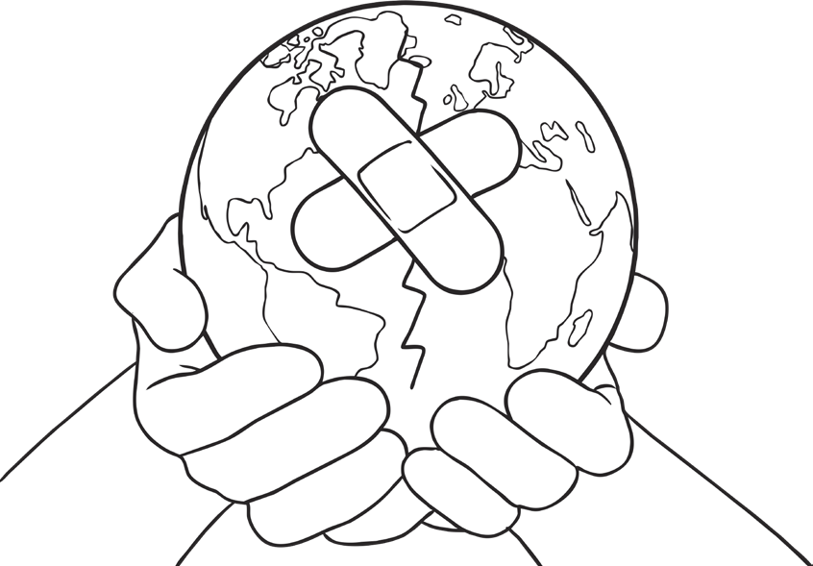
5 Ways I Can Help Our Earth

