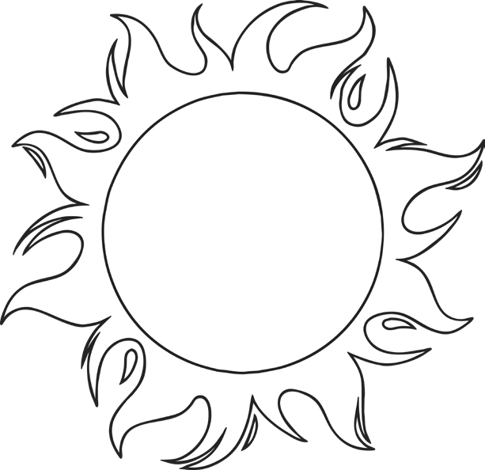
The Sun
The Sun is a . It can be found at the of our solar system. The sun is the biggest thing in our solar system and scientists estimate that it is about 4.5 years old. The between planet Earth and the Sun is about 150 million kilometres.

Our planet, Earth, is constantly moving around the Sun.
It takes 365 ¼ days for planet Earth to one full circle around the Sun. This explains
why there are 365 days in a year and why there is an extra day, every four years, in a leap year.

While Earth is moving around the Sun, it is also spinning on its own axis. It takes Earth 24 hours to complete one full spin. This gives us and night. During the summer we have longer days and shorter nights, but during the winter we have shorter days and longer nights. The day of the year, the winter solstice, is on 21st December. The longest day of the year, the summer , is on 21st June.

An happens when the moon moves in between the Earth and the Sun. This causes the Sun’s light to be blocked from reaching the earth for a short time.

The Sun is extremely important for life on Earth, without it, we would not have light, heat or food and we would not be able to . But we must also be cautious about the Sun because it can be too. Our skin can burn if we spend too much time in the sunlight. The rays from the sun can damage our eyes. We can ourselves from the dangers of the sun by wearing suitable sunglasses and sun cream.

 |  | Word Bank
complete | survive | day | star | ultraviolet
eclipse | shortest | protect | distance | billion
 | solstice | dangerous | centre

